Standard Channel Nomenclature for the Public Safety Interoperability Channels

Candidate APCO ANS 1.104.2-201X
Standard written by The NPSTC Interoperability Committee Channel Naming Working Group Approved April 5, 2010 by APCO International Standards Development Committee (SDC) Approved June 9, 2010 by The American National Standards Institute (ANSI)
(APCO will insert update activity)
Abstract: Standard nomenclature for FCC and NTIA-designated nationwide interoperability channels used for public safety voice communications. The public safety community uses spectrum allocated by the FCC and NTIA in multiple bands that is replete with interoperability channels. It is necessary to develop and employ a common set of channel names so that all responders to an incident know which channel to tune their radios to, as well as the band and primary use for the channel.
Keywords: public safety channel nomenclature, radio channel names, interoperability, responders, incidents, channel band, fire services, emergency medical services, law enforcement and public safety communications.

Table of Contents*
Foreword* 1
Acknowledgements* 4
NPSTC Interoperability Committee Channel Naming Workgroup 4
APCO Standards Development Committee (SDC) 5
Acronyms and Abbreviations* 6
Candidate APCO ANS 1.104.2-201x 7
Introduction 7
NTIA Interoperability Channels* 7
700 MHz Spectrum* 8
Public Safety Interoperability Use of VHF Maritime Spectrum* 9
Implementing This Protocol* 9
Standardized FCC Interoperability Channel Naming Format 10
Standardized Tone Squelch or Network Access Codes 12
Analog Operations 12
Digital Operations 13
Subscriber Radio Programming 14
Interoperability Channel Configurations 14
Limitations* 16
Appendix: 18
Table 1: Sorted by Band in Numeric Order* 18
Table 2: Sorted by Frequency* 18
Table 1: Sorted by Band in Numeric Order* 19
Table 1: Sorted by Band in Numeric Order* 20
Table 1: Sorted by Band in Numeric Order* 21
Table 1: Sorted by Band in Numeric Order* 22
Table 1: Sorted by Band in Numeric Order* 23
Table 2: Sorted by Frequency* 24
Table 2: Sorted by Frequency* 25
Table 2: Sorted by Frequency* 26
Table 2: Sorted by Frequency* 27
Table 2: Sorted by Frequency* 28

Foreword*
The Association of Public-Safety Communications Officials (APCO) International is the world’s oldest and largest professional organization dedicated to the enhancement of public-safety communications. APCO International serves the professional needs of its 15,000 members worldwide by creating a platform for setting professional standards, addressing professional issues and providing education, products and services for people who manage, operate, maintain, and supply the communications systems used by police, fire, and emergency medical dispatch agencies throughout the world.
The 2014-2015 APCO International Board of Directors:
- John Wright, President
- Brent Lee, First Vice President
- Cheryl Greathouse, Second Vice President
- Georggina Smith, Immediate Past President
- Derek Poarch, Ex-Officio

The National Public Safety Telecommunications Council (NPSTC) is a federation of public safety organizations whose mission is to improve public safety communications and interoperability through collaborative leadership. NPSTC pursues the role of resource and advocate for public safety organizations in the United States on matters relating to public safety telecommunications. NPSTC has promoted implementation of the Public Safety Wireless Advisory Committee (PSWAC) and the 700 MHz Public Safety National Coordination Committee (NCC) recommendations. NPSTC explores technologies and public policy involving public safety telecommunications, analyzes the ramifications of particular issues and submits comments to governmental bodies with the objective of furthering public safety telecommunications worldwide. NPSTC serves as a standing forum for the exchange of ideas and information for effective public safety telecommunications.
The following 17 organizations serve on the NPSTC governing board:

- American Association of State Highway and Transportation Officials
- American Radio Relay League
- Association of Emergency Managers
- Association of Fish and Wildlife Agencies
- Association of Public-Safety Communications Officials-International
- Forestry Conservation Communications Association
- International Association of Chiefs of Police International
- International Association of Emergency Managers
- International Association of Fire Chiefs
- International Municipal Signal Association
- National Association of State Chief Information Officers
- National Association of State Emergency Medical Services Officials
- National Association of State Foresters
- National Association of State Technology Directors
- National Council of Statewide Interoperability Coordinators
- National Emergency Number Association
- National Sheriff’s Association

APCO International standards are developed by APCO committees, projects, task forces, workgroups, and collaborative efforts with other organizations coordinated through the APCO International Standards Development Committee (SDC). Members of the committees are not necessarily members of APCO. Members of the SDC are not required to be APCO members. All members of APCO’s committees, projects, and task forces are subject matter experts who volunteer and are not compensated by APCO. APCO standards activities are supported by the Comm. Center & 9-1-1 Services Department of APCO International.
APCO American National Standards (ANS) are voluntary consensus standards. Use of any APCO standard is voluntary. This standard does not imply that there are no other guides for public safety channel nomenclature. All standards are subject to change. APCO ANS are required to be reviewed no later than every five years. The designation of an APCO standard should be reviewed to ensure you have the latest edition of an APCO standard, for example:
APCO ANS 1.104.3-2015 = 1 – Operational, 2 – Technical, 3 – Training
APCO ANS 1.104.32015 = Unique number identifying the standard
APCO ANS 1.104.3-2015 = The edition of the standard, which will increase after each revision
APCO ANS 1.104.3-2015 = The year the standard was approved and published, which may change after each revision.
The latest edition of an APCO standard cancels and replaces older versions of the APCO standard.
Comments regarding APCO standards are accepted any time and can be submitted to standards@apcointl.org, if the comment includes a recommended change, it is requested to accompany the proposed change with supporting material. If you have a question regarding any portion of the standard, including interpretation, APCO will respond to your request following its policies and procedures. ANSI does not interpret APCO standards; they will forward the request to APCO.
APCO International adheres to ANSI’s Patent Policy. Neither APCO nor ANSI is responsible for identifying patents for which a license may be required by an American National Standard or for conducting inquiries into the legal validity or scope of any patents brought to their attention. No position is taken with respect to the existence or validity of any patent rights within this standard. APCO is the entity that may authorize the use of trademarks, certification marks, or other designations to indicate compliance with this standard.
Permission must be obtained to reproduce any portion of this standard and can be obtained by contacting APCO International’s Comm Center & 9-1-1 Services Department. Requests for information, interpretations, and/or comments on any APCO standards should be submitted in writing addressed to:
APCO SDC Secretary, Comm Center & 9-1-1 Services
APCO International
351 N. Williamson Blvd
Daytona Beach, FL 32114 USA
standards@apcointl.org
For more information regarding APCO standards, please visit www.apcostandards.org

Acknowledgements*

NPSTC Interoperability Committee Channel Naming Workgroup
The NPSTC Interoperability Committee Channel Naming Workgroup would like to thank the following for their contributions to this revised standard:

John Lenihan, Chair
NPSTC Interoperability Committee
Don Root
San Diego County Sheriff’s Department, CA (Workgroup Chair)
Gary Davis, Jr.
Maryland State Police, Director
Matthew Delaney
State of New York Department of Homeland Security
Steve Devine
APCO International
James Downes
DHS Office of Emergency Communications
Toby Dusha
NYS Division of Homeland Security & Emergency Services
David Eierman
Motorola, Inc,

Carl Guse
Wisconsin State Patrol
John Lemmon
California Governor's Office of Emergency Services
Barry Luke
NPSTC
Terry Nehring
City of Tampa, FL
Ross Merlin
DHS, National Coordinating Center for Communications
John Powell
California Governor's Office of Emergency Services
Carlton Wells
State of Florida
Steve Weston
L.A. County Fire Department
Marilyn Ward
NPSTC

APCO Standards Development Committee (SDC)
At the time this standard received ANS designation, the APCO Standards Development Committee (SDC) had the following membership:
Frank Kiernan, Chair
Meriden Emergency Communications, CT

Sherry Taylor, Vice Chair
Indianapolis Fire Department Communications Division, IN

Chris Fischer
APCO Past President, WA

Mark J. Fletcher, ENP
AVAYA, NJ

Jason Friedburg
EmergenSee, PA
James Leyerle, ENP
OnStar, MI
Nate McClure, ENP
AECOM. VA
Daniel Morelos
Tucson Airport Authority, AZ

Michael Romano
NexGen Global Technologies, FL
Jerry Schlesinger
City of Portland, OR
Bradford S. Smith
Framingham Fire Department, MA

Kayla Stein, RPL
St. Tammany Fire District 12, LA

Judith Weshinsky-Price, ENP, RPL
Amarillo Emergency Communications Center, TX

Crystal McDuffie, ENP, RPL, Secretary
APCO International

Acronyms and Abbreviations*
For the purposes of this ANS, the following definitions of acronyms apply:
ANS | American National Standard
ANSI | American National Standard Institute
APCO | Association of Public-Safety Communications Officials – International
CAPRAD | Computer Assisted Pre-coordination Resource And Database system
CASM | Communications Asset Survey and Mapping tool
CFR | Code of Federal Regulations
CTCSS | Continuous Tone Controlled Squelch System
FCC | Federal Communications Commission
IRAC | Interdepartmental Radio Advisory Committee
LE | Law Enforcement
MHz | Megahertz
NAC | Network Access Code
NCC | Public Safety National Communications Coordination Committee
NIIX | National Interoperability Information eXchange
NPSPAC | National Public Safety Planning Advisory Committee
NPSTC | National Public Safety Telecommunications Council
NTIA | National Telecommunications and Information Administration
PSAP | Public Safety Answering Point
RPC | Regional Planning Committee
SIEC | Statewide Interoperability Executive Committee
UHF | Ultra-High Frequency
VHF | Very High Frequency
VPSCA | VHF Public Coast Service Area

Candidate APCO ANS 1.104.2-201x

Introduction
This document outlines the Standard Channel Nomenclature for Public Safety Interoperability Channels as revised in 2015. The requirement for a common naming protocol for public safety’s interoperability frequencies was identified in early 2000 by the Public Safety National Coordination Committee (NCC), a Federal Advisory Committee chartered by the Federal Communications Commission (FCC) that operated from 1999 to 2003, and provided recommendations to the Commission on operational and technical parameters for use of the 700 MHz public safety band.
Document History
In the final report of the NCC on July 25, 2003, Chair Kathleen Wallmann wrote:
Standard Channel Nomenclature
“The NCC respectfully renews its earlier recommendation that the Commission’s Rules contain mandatory channel nomenclature for all interoperability channels on all public safety bands. The NCC views such standard nomenclature as essential to the interoperability process, such that all responders to an incident will know the appropriate channel to which to tune their radios and will know – from the channel designator – the band and primary use of the channel specified. Absent such standard nomenclature, confusion could result if, for example, a given jurisdiction was to designate frequency 458.2125 MHz as a calling channel and associate it with “Channel 5” on its radios; and another jurisdiction were to designate the same frequency as a tactical channel and assign it to “Channel 9” on its radios. With adoption of a standard channel nomenclature in the Rules, such confusion – and the attendant potential for delayed response to an incident – would be avoided…”
While the FCC declined at that time to mandate such a standard channel nomenclature, the NCC protocol has received wide acceptance within the public safety communications community, as communications interoperability for public safety’s first responders continues to be a major issue.
During 2006 NPSTC was approached by a number of public safety user organizations with a request that NPSTC review and update the Standard Channel Nomenclature to reflect ‘real world’ user operational requirements. A Task Group was convened and a public forum to address the issue was held on February 5, 2007, in Orlando, Florida. Six proponent organizations submitted recommendations for modification of the Standard Channel Nomenclature. These were heard and discussed at the forum, and a consensus format was adopted. The proposed revision (as a Report of Committee) was placed on public notice, and after a 90-day comment period, adopted as this revised protocol.

NTIA Interoperability Channels*
During the forum, the issue of names for the 40 National Telecommunications and Information Administration (NTIA) VHF and UHF Interoperability Channels was discussed. In 2001 the NTIA designated these channels with a set of unique names. The channels were made available for licensing by state and local entities through a process outlined in FCC Public Notice DA-1621, released July 13, 2001. The use of different names by at least one large federal entity continues to cause confusion among first responders.
The representatives of the various federal agencies present requested that the Task Group take the issue of the NTIA channels off line and work with them to find a solution that works for all parties.
The Interdepartment Radio Advisory Committee (IRAC) AD HOC 214 group addressed the issue, obtained naming consensus within the Federal public safety community, and has reported out that the existing naming convention will remain as-is due to the large number of existing federal subscriber sets in use. The AD HOC 214 co-conveners have agreed to request that the FCC update the information contained in DA-1621 and issue a new Public Notice.
This document includes the 40 NTIA VHF and UHF Interoperability Channels with the NTIA naming format and Tone Squelch / Network Access information. State and local public safety agencies who may program these channels into subscriber radio equipment should place these channels into a separate bank named “Fed” or “NTIA” as a method of avoiding user confusion with any similarly named local operating frequencies.

700 MHz Spectrum*
During NPSTC’s 2007 Comment Period for the Report of Committee, the FCC released Docket 07-72, a Report and Order and Further Notice of Proposed Rulemaking addressing seven different ongoing dockets relating to the Lower and Upper 700 MHz Bands (including the public safety segments in TV Channels 63, 64, 68, and 69). Among the numerous issues in this docket, the Commission announced the intent to realign the public safety allocations to combine the two separate segments of paired narrowband channels into the Channel 64/69 pair, and combine the non-narrowband voice use into Channel 63/68, and reallocate the use to broadband data which could reduce or eliminate the designators for wideband data interoperability channels. The original FCC allocations for the narrowband interoperability spectrum included duplicate sets of channels (e.g.: Call, Data I/O, Secondary Trunking, etc.), that are reflected in the current protocol. At this time, NPSTC has elected to refrain from making any adjustments to the protocol until such time as the issues raised in the Further Notice are resolved by the FCC.
The Second Report and Order (FCC 07-132), released August 12, 2007, consolidated the two separate narrowband voice blocks into one segment of the 700 MHz band, but did not address the issue of duplicate calling and data interoperability channels. Subsequent to the release of the Second Report and Order NPSTC has filed a Request for Rulemaking asking the FCC in part to address the duplicate Calling and Data Interoperability channel designation. The 2010 revision of this standard consolidated the former split blocks of 700 MHz channels and changed the frequency information from the FCC Channel Number format in the NCC and previous NPSTC versions to the discrete 700 MHz frequencies, listing 12.5 kHz channels in order to facilitate the use of the Project 25 Phase 1 Common Air Interface.
On October 24, 2014 the FCC released a Report and Order (FCC 14-172) on PS Docket 13-87 addressing a number of changes to the 700 MHz spectrum rules. These include a re-designation of 700 MHz non-interoperability channels from secondary trunked use to low-power, low-level Air-Ground use; allowing for voice use of the two data interoperability channels on a secondary basis; and clarified that the use of analog emissions is not permitted on the 700 MHz interoperability channels.
This revision of the Standard Channel Nomenclature incorporates the changes to the 700 MHz spectrum rules, adds the eight 12.5 kHz Air-Ground channels, adds a VHF channel commonly used for Search and Rescue (SAR) operations, and corrects a number of typographical errors. The Tables in the Appendix have been reformatted to follow the format of the ICS-217a COMMUNICATIONS RESOURCE AVAILABILITY WORKSHEET, facilitating the importation of the data into emergency operations Incident Action Plan documents.

Public Safety Interoperability Use of VHF Maritime Spectrum*
In its Third Memorandum Opinion and Order and Third Report and Order, FCC 00-348 released October 10, 2000, the FCC designated three maritime VHF channel pairs for public safety interoperability use in 33 inland VHF Public Coast Service Areas (VPSCAs). One channel pair was designated for use in all 33 VPSCAs, and the other two pairs were designated by VPSCA, so as to provide two pairs for use in each inland VPSCA. These channels had been listed in earlier drafts of this document as VTAC17/17D, VTAC18/18D, and VTAC19/19D.
In its Second Report and Order (FCC 08-208) on WT Docket 04-344, released September 19, 2008, the FCC removed VHF Maritime Channels 84 (VTAC18/18D) and 85 (VTAC19/19D) from public safety interoperability use in the 33 inland VPSCAs. VHF Maritime Channel 25 (VTAC17/17D) remains available for use in the 33 inland VPSCAs.
VTAC18/18D and VTAC19/19D have been removed from this standard.

Implementing This Protocol*
It is recognized that the implementation of this protocol should be done in an organized and coordinated manner. This is best accomplished in conjunction with a system programming refresh, such as when other operational requirements such as a frequency change requires the subscriber fleet of radios to be adjusted. It is also important that dispatch consoles be programmed to display the correct common channel name which matches the name programmed in subscriber radios. This is an essential step to insure that the correct interoperability channel is referenced by the telecommunicators when communicating with the first responder.
This document provides a standardized naming format as the single reference for the common identification of public safety interoperable radio channels. For reference purposes only, this document also contains an Appendix with FCC public safety channel allocation tables. The tables may be subject to future FCC rule changes; however, the standardized naming format has been constructed in a manner to provide a rule and guide to channel identifiers independent of FCC future actions. The standard will be subject to periodic review and updates as required by APCO International and ANSI Standards Development policies and procedures.

Standardized FCC Interoperability Channel Naming Format
Each FCC designated Interoperability Channel in the Public Safety Radio Services (47CFR Part 90) shall have a unique name developed according to a standardized format. This format consists of a maximum of eight characters, the eight-character limit was adopted after discussions with major equipment manufacturers determined this was the minimum display being delivered in 2003 for radios ordered with a display option.
This eight-character size was again confirmed with several manufacturers in early 2007. Following the February 2007 NPSTC meeting where the naming format was finalized, a number of agencies presented a strong case for six character names for some channels where radios cannot, for technical reasons, support the eight character names. The six-character name shall only be used in equipment that is not capable of implementing the eight character names. The names shall be programmed exactly as specified without the addition of any extraneous characters or spaces. Channel names in this format are reserved for nationwide frequency naming and are not to be used for local or statewide frequency naming use.
The standard naming format is as follows:
Btype##M
This format is broken down as follows:
B Spectrum Band
The Spectrum Band designator is a unique single alpha or numeric character to designate the public safety spectrum segment the channel is found within:
L VHF Low Band (30 – 50 MHz)
V VHF High Band (150.8 – 162.0 MHz) – Not used for channel names in six-character format.
U UHF Band (450 – 470 MHz) - Not used for channel names in six-character format.
7 700 MHz Public Safety Narrowband Voice Band (769 – 775 / 799 – 805 MHz).
8 800 MHz NPSPAC band after the rebanding process (806 – 809 / 851 – 854 MHz) - Not used for channel names in six-character format.
Type Channel Use Designator
The Channel Use Designator is an alphanumeric three or four place tag to signify the primary purpose of operations on the channel. In some cases, the Channel Use has been specified in FCC Rules or related Orders. To facilitate the use of these Channel Names in older radios with only 6 characters available in the display, the first “Band” character is deleted, and the “type” Channel Use field is limited to the first 3 characters. Short Form names are not applicable to the 700 MHz Band since equipment for this band is new and does not have the character limitation.
8 Character format | 6 Character Format | Definition
AG | AG | Channel is dedicated nationwide for the express purpose of low power, low level (less than 1500’ AGL) Air-Ground operations
CALL | CAL | Channel is dedicated nationwide for the express purpose of interoperability calling only.
DATA | DAT | Channel is primarily used for the purpose of low speed data transmission. Voice use is permitted on a secondary basis.
FIRE | FIR | Channel is primarily used for interagency incident communications by Fire licensees
GTAC | GTC | Channel is primarily used for interagency incident communications between Public Safety eligible entities and eligible non-governmental organizations.
LAW | LAW | Channel is primarily used for interagency incident communications by Police licensees.
MED | MED | Channel is primarily used for interagency incident communications by Emergency Medical Service licensees.
MOB | MOB | Channel is primarily used for on-scene interagency incident communications by any Public Safety eligible, using vehicular repeaters (FCC Station Class MO3). **
SAR | SAR | Channel is primarily used for interagency incident communications for Search and Rescue Operations. **
TAC | TAC | Channel is primarily used for interagency communications by any Public Safety eligible. **
TRVL | TRV | Channel is primarily used for interagency communications by any Public Safety eligible to coordinate travel when responding to/from an incident outside of an agency's own jurisdiction.
**These channels are generally incident-based and not used for wide-area communications.
## Unique Channel Identifier
The Unique Channel Identifier is a numeric one or two place tag to uniquely identify the specific channel. Channel Identifiers are grouped by band segment as follows:
1-9 VHF Low Band (30-50 MHz) [No leading zero used] 10-39 VHF High band (150.8 – 162 MHz)
40-49 UHF band (450 – 470 MHz)
50-89 700 MHz (769 – 775 / 799 – 805 MHz)
90-99 800 MHz “NPSPAC” band (806-809/851-854 MHz) [Post-rebanding]
Notes:
Starting in VHF High Band, Channel Identifiers are grouped by Channel Use type, with Channel Identifiers ending in “0” generally reserved for Interoperability Calling use.
Channels Identifiers specified for Emergency Medical Services (“MED”) in this document are numbered to avoid conflict with the FCC’s UHF medical channel naming methodology specified in 47CFR90.20(d)(65) and 47CFR90.20(d)(66)(i).
If a new frequency becomes available, it will be given the next unique channel identifier.
M Modifier
The Modifier character is a single alphanumeric tag to identify a modification to the default operation type on the channel/channel pair:
D Direct or “Talk around” use [Simplex operations on the output channel of a pair normally designated for half-duplex or mobile relay operations.]

Standardized Tone Squelch or Network Access Codes
The use of a common Continuous Tone Controlled Squelch System (CTCSS) tone of 156.7 Hz for transmit and receive on national Interoperability Channels was originally specified in the NPSPAC proceedings (FCC Docket 87-112). In many areas, the 800 MHz Planning Regions allow the use of an additional (secondary) access tone for in-cabinet repeat operations by repeater stations, as long as the 156.7 Hz tone was monitored by a live dispatcher or always repeated upon receipt. 156.7 Hz shall always be transmitted by repeaters. It is recommended that the issue of CTCSS/NAC (Network Access Code) migration from “all carrier squelch operation” to “CTCSS/NAC for receive only” to “full CTCSS/NAC use” be addressed on a state-to-state basis as a statewide issue by 700/800 MHz Regional Planning Committees (RPCs) and/or Statewide Interoperability Executive Committees (SIECs) who would develop a schedule for CTCSS/NAC migration across that entire state.
In the development process of the Standard Channel Nomenclature for the Public Safety Interoperability Channels, the NCC Interoperability Committee’s Working Group recommended that 156.7 Hz CTCSS transmit and receive be used for all analog voice operations on all interoperability channels in all bands. For P-25 voice operations, the NCC Working Group initially recommended the 156.7 Hz equivalent NAC of $61F. This recommendation was changed in 2001 to use the default (“carrier squelch equivalent”) NAC of $293.
The NTIA has adopted 167.9 Hz as the common CTCSS tone to be used on NTIA analog interoperability frequencies. NTIA adopted a NAC of $68F for use on NTIA digital interoperability frequencies.

Analog Operations
CTCSS Tone 156.7 Hz shall be used for all analog operations on Interoperability Channels:
- All (fixed and subscriber) analog subscriber equipment shall encode and decode 156.7 Hz with the following exceptions:
  - Transportable relay stations deployed on VTAC channels (VTAC33, 34, 35, 36, 37, 38) shall be configured to encode 156.7 Hz and decode 136.5 Hz. Subscriber radio operating on these pairs shall encode 136.5 Hz.
  - Fixed and subscriber equipment operating on 155.1600 (VSAR16) should encode 127.3 Hz.
- Subject to the approval of applicable Statewide Communications Interoperability Plans and/or FCC-approved Regional Plans, mobile relay (repeater) stations that are part of a local, regional, or statewide interoperability network may be equipped with a second receive CTCSS tone to provide local (“in cabinet”) mobile relay operation, provided:
  - The relay transmitter continues to transmit the common CTCSS tone of 156.7 Hz so that all users within range of the station are aware the station is in use;
  - The relay will accept the common CTCSS tone of 156.7 Hz and present the audio accompanying the156.7 Hz-encoded transmissions for automatic in-cabinet repeat or to a live operator at the appropriate controlling dispatch facility; and
  - The operational configuration of the mobile relay station is published in applicable interoperability resource tracking documents (such as the appropriate Tactical Interoperability Communications Plan, Statewide Communications Interoperability Plan, and/or FCC-approved Regional Plan) and databases (CAPRAD, CASM, and NIIX).

Digital Operations
Network Access Code (NAC) $293 shall be used for all digital operations on FCC-designated Interoperability Channels where digital modulation is permitted or required, as follows:
- Subject to the approval of applicable Statewide Communications Interoperability Plans and/or FCC-approved Regional Plans, mobile relay (repeater) stations that are part of a local, regional, or statewide interoperability network may be equipped with a second receive NAC to provide local (“in cabinet”) mobile relay operation, provided:
  - The relay transmitter shall continue to transmit the Common NAC of $293 so that all users within range of the station are aware the station is in use;
  - The relay shall accept the Common NAC of $293 and present the audio accompanying the $293-encoded transmission for automatic in-cabinet repeat or to a live operator at the appropriate controlling dispatch facility; and
  - The operational configuration of the mobile relay station shall be published in applicable interoperability resource tracking documents (such as the appropriate Tactical Interoperability Communications Plan, Statewide Communications Interoperability Plan, and/or FCC-approved Regional Plan) and databases (CAPRAD, CASM, and NIIX).
- NTIA Law Enforcement (LE) channels when operating in digital mode use NAC $68F. These LE channels all operate in digital mode except LE A, LE B, LE 1, LE 10 and LE 16 which operate in analog mode using 167.9 Hz TX CTCSS.

Subscriber Radio Programming

Interoperability Channel Configurations
Interoperability channels listed with both a mobile relay and a direct configuration should have both configurations of each channel programmed in each subscriber radio, regardless of the available infrastructure in the user’s home area.
State and local public safety and public service agencies programming the NTIA VHF and UHF Law Enforcement and Incident Response channels into their subscriber equipment should partition those channels into a separate ‘zone’ or ‘bank’ designated as “FED” or “NTIA,” while maintaining the NTIA Channel designation, as a method to avoid confusion on the user’s part between the NTIA channels and any similarly designated local channels.
Subscriber Channel Configuration*
Tables 1 and 2 have a column labeled ‘Subscriber Channel Configuration (B, F, M)’, with the indicators of “B”, “F” and “M”. These indicators signify the type of stations used on the channel.
B: Base
This category includes:
Base station (FCC Station Class FB or FBT). A station at a specified site authorized to communicate with mobile stations.
Mobile relay station (FCC Station Class FB2 or FB2T). A base station in the mobile service authorized to retransmit automatically on a mobile service frequency those communications which originate on the transmitting frequency of the mobile station.
F: Fixed
This category includes:
Control station (FCC Station Class FX1 or FX1T). An Operational Fixed Station, the transmissions of which are used to control automatically the emissions or operation of another radio station at a specified location.
M: Mobile
This category includes:
Mobile station (FCC Station Class MO). A station in the mobile service intended to be used while in motion or during halts at unspecified points. This includes hand carried transmitters.
Mobile repeater station (FCC Station Class MO3). A mobile station authorized to retransmit automatically on a mobile service frequency, communications to or from hand-carried transmitters.
Transmitter Deviation*
Tables 1 and 2 have a column labeled ‘Dev’, with the indicators of “N” or “W”. These indicators signify the bandwidth of transmitted signals on the channel.
N: Narrow – 12.5 kHz or less
This category includes P25 digital (8K0 type emissions) and narrow analog (11K type emissions).
W: Wide – Greater than 12.5 kHz
This category includes 16K or 20K type analog emissions.
Transmitter Power *
Tables 1 and 2 have a column labeled ‘Pwr’, with the indicators of “H” or “L”. These indicators signify the transmitter power used on the channel.
H: High
Operations on this channel have no transmitter power limitations and may be conducted at normal transmitter power levels.
L: Low
Operations on this channel are to be conducted at low power. See the ‘Limitations’ for the channel for details.
Operational Mode*
Tables 1 and 2 have a column labeled ‘Mode A or D’, with the indicators of “A” or “D”. These indicators signify the operating mode (analog or digital) used on the channel.
A: Analog
Operations on this channel are conducted using analog (emission class F3E) emissions.
D: Digital
Operations on this channel are conducted using digital (Project 25 Phase 1 Common Air Interface) emissions.

Limitations*
Tables 1 and 2 refer to various limitations. These limitations refer to sections of 47 CFR Part 90, the FCC’s Rules and Regulations for Public Safety use of the radio spectrum. These limitations are:
90.16 90.16 Public Safety National Plan.
The Commission has established a National Plan which specifies special policies and procedures governing the Public Safety Pool (formally Public Safety Radio Services and the Special Emergency Radio Service). The National Plan is contained in the Report and Order in General Docket No. 87-112. The principal spectrum resource for the National Plan is the 806-809 MHz and the 851-854 MHz bands at locations farther then 110 km (68.4 miles) from the U.S./Mexico border and 140 km (87 miles) from the U.S./Canadian border (``border regions''). In the border regions, the principal spectrum for the National Plan may be different. The National plan establishes planning regions covering all parts of the United States, Puerto Rico, and the U.S. Virgin Islands. No assignments will be made in the spectrum designated for the National Plan until a regional plan for the area has been accepted by the Commission.
90.20(d)(15) (15) This frequency is reserved for assignment to stations for intersystem operations only: Provided, however, that licensees holding a valid authorization to use this frequency for local base or mobile operations as of June 1, 1956, may continue to be authorized for such use.
90.20(d)(16) (16) This frequency is reserved primarily for assignment to state police licensees. Assignments to other police licensees will be made only where the frequency is required for coordinated operation with the state police system to which the frequency is assigned. Any request for such assignment must be supported by a statement from the state police system concerned indicating that the assignment is necessary for coordination of police activities.
90.20(d)(19) (19) This frequency is reserved for assignment to stations in this service for intersystem operations only and these operations must be primarily base-mobile communications.
90.20(d)(28) (28) This frequency is not available for assignment in this service in Puerto Rico or the Virgin Islands.
90.20(d)(40) (40) This frequency may be designated by common consent as an intersystem mutual assistance frequency under an area-wide medical communications plan.
90.20(d)(41) (41) This frequency is available nationwide for use in police emergency communications networks operated under statewide law enforcement emergency communications plans.
90.20(d)(80) (80) After December 7, 2000 this frequency is available primarily for public safety interoperability only communications. Stations licensed prior to December 7, 2000 may continue to use this frequency on a co-primary basis until January 1, 2005. After January 1, 2005, all operations will be secondary to co-channel interoperability communications.
90.20(d)(83) (83) This interoperability frequency is dedicated for the express purpose of nationwide interoperability calling.
90.20(g) (g) Former public correspondence working channels in the maritime VHF (156–162 MHz) band allocated for public safety use in 33 inland Economic Areas. … (2) In VHF Public Coast Service Areas (VPCSAs) 10–42, the duplex channel pair 157.250 MHz/161.850 MHz (VHF Maritime Channel 25) is allocated for public safety use by entities eligible for licensing under paragraph (a) of this section, and is designated primarily for the purpose of interoperability communications. See 47 CFR 80.371(c)(1)(ii) for the definitions of VPCSAs..
90.531(b)(1)(i) (i) Narrowband data Interoperability channels. The following channel pairs are reserved nationwide for the express purpose of data transmission only … Voice operations are permitted on these channels on a secondary basis.
90.531(b)(1)(ii) (ii) Narrowband calling Interoperability channels. The following channel pairs are dedicated nationwide for the express purpose of Interoperability calling only … They may not be used primarily for routine, day-to-day communications. Encryption is prohibited on the designated calling channels.

90.531(b)(1)(iii) (iii) Narrowband trunking Interoperability channels. The following Interoperability channel pairs may be used in trunked mode on a secondary basis to conventional Interoperability operations…
90.531(b)(7) (7) Air-Ground Channels. The following channels are reserved for air-ground communications to be used by low-altitude aircraft and ground based stations: …
(i) Airborne use of these channels is limited to aircraft flying at or below 457 meters (1500 feet) above ground level.
(ii) Aircraft are limited to 2 watts effective radiated power (ERP) when transmitting while airborne on these channels.
(iii) Aircraft may transmit on either the mobile or base transmit side of the channel pair.
(iv) States are responsible for the administration of these channels.

Appendix:

Table 1: Sorted by Band in Numeric Order*

Table 2: Sorted by Frequency*

Table 1: Sorted by Band in Numeric Order*
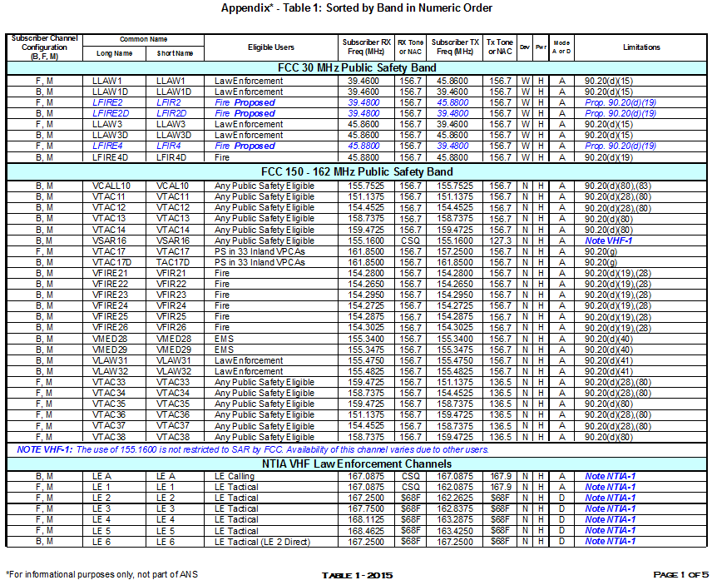

Table 1: Sorted by Band in Numeric Order*
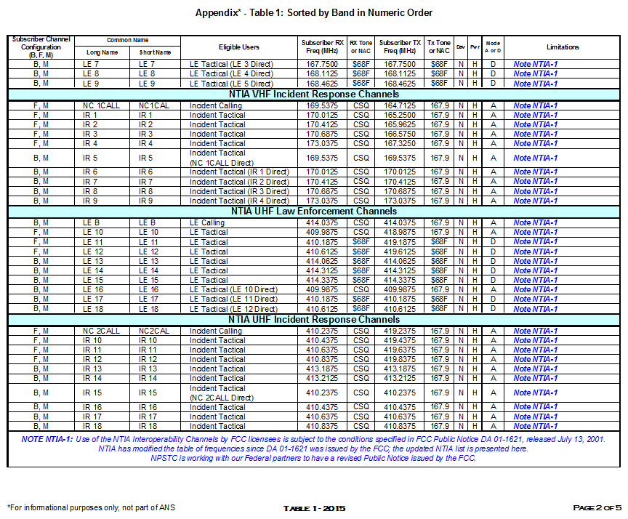

Table 1: Sorted by Band in Numeric Order*
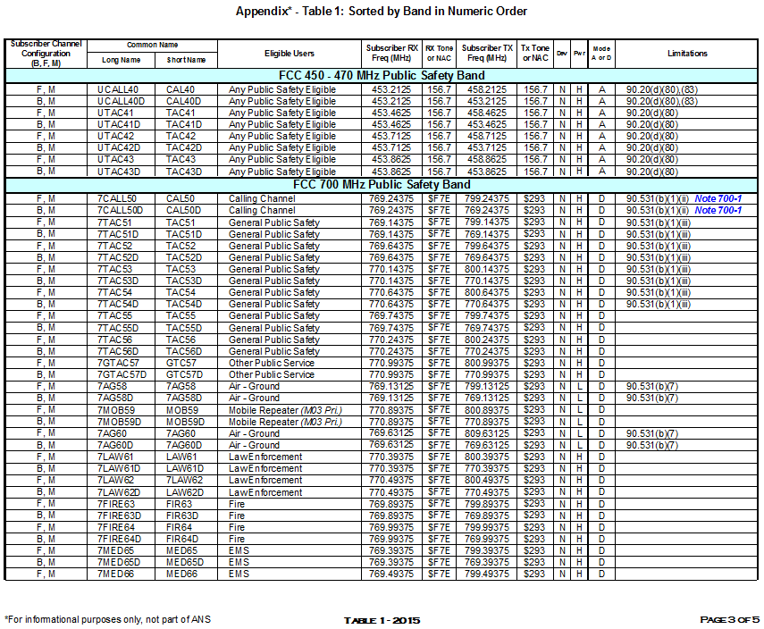

Table 1: Sorted by Band in Numeric Order*
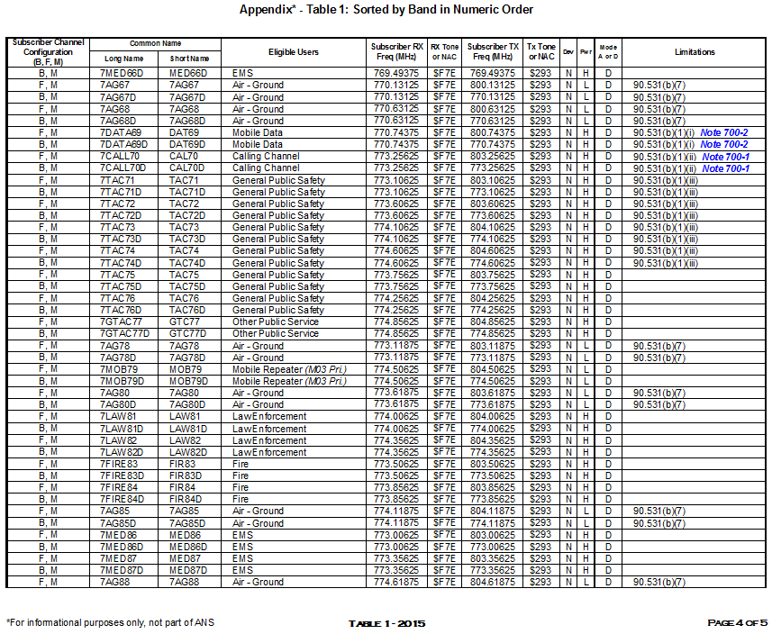

Table 1: Sorted by Band in Numeric Order*
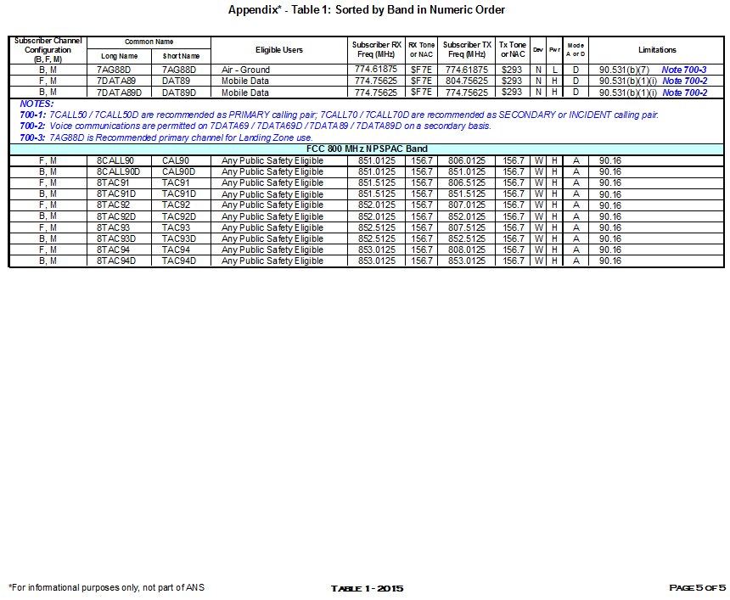

Table 2: Sorted by Frequency*
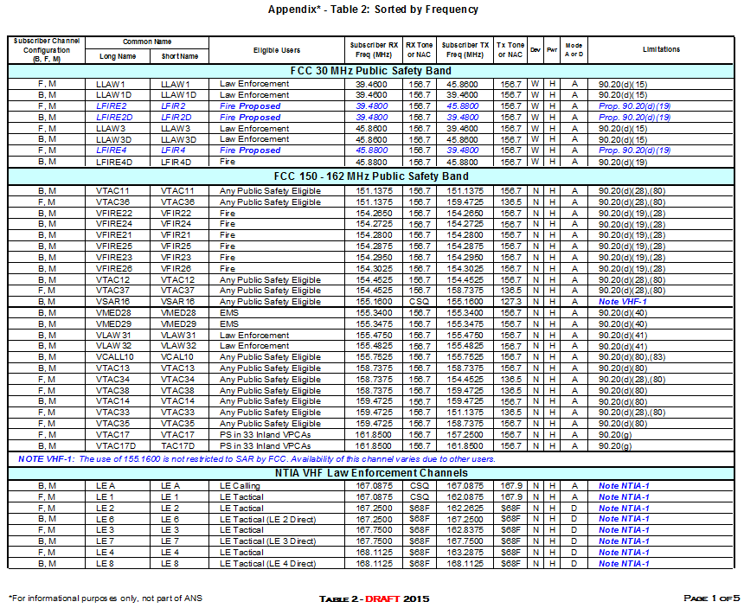

Table 2: Sorted by Frequency*
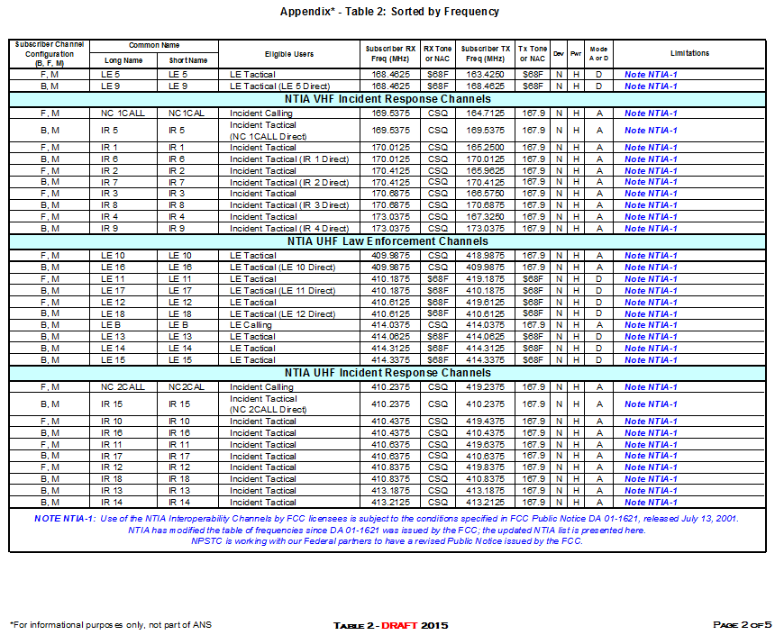

Table 2: Sorted by Frequency*
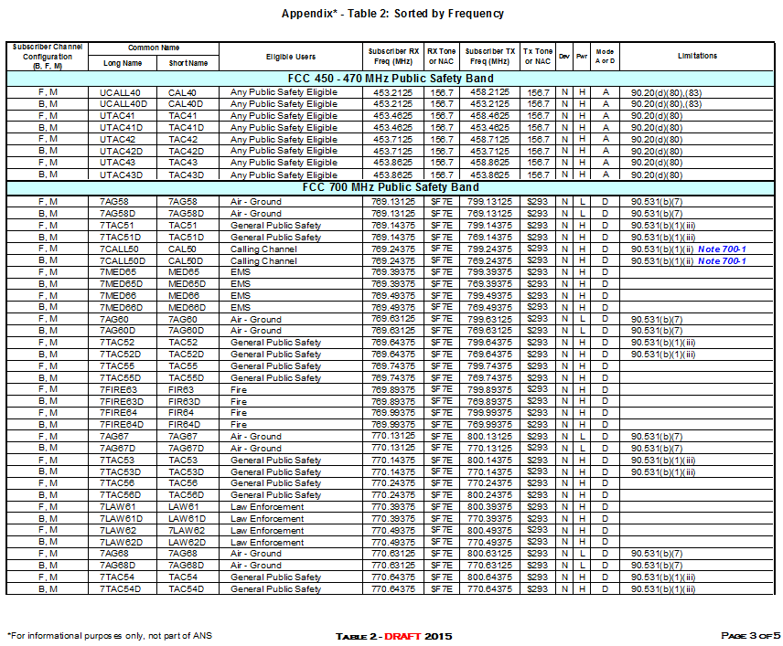

Table 2: Sorted by Frequency*
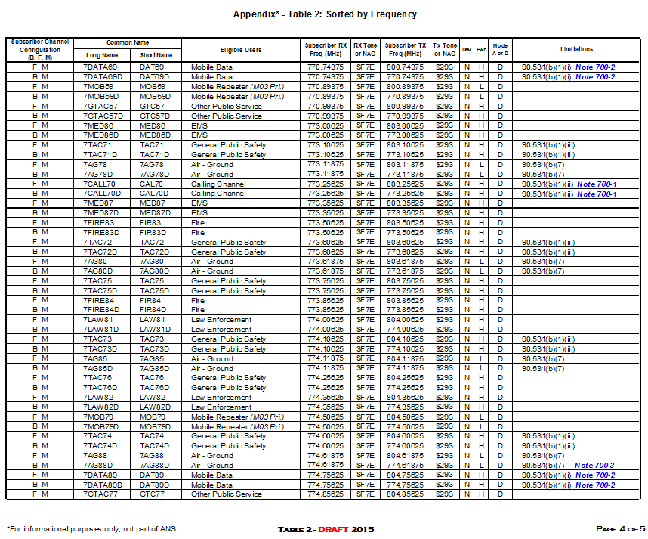

Table 2: Sorted by Frequency*
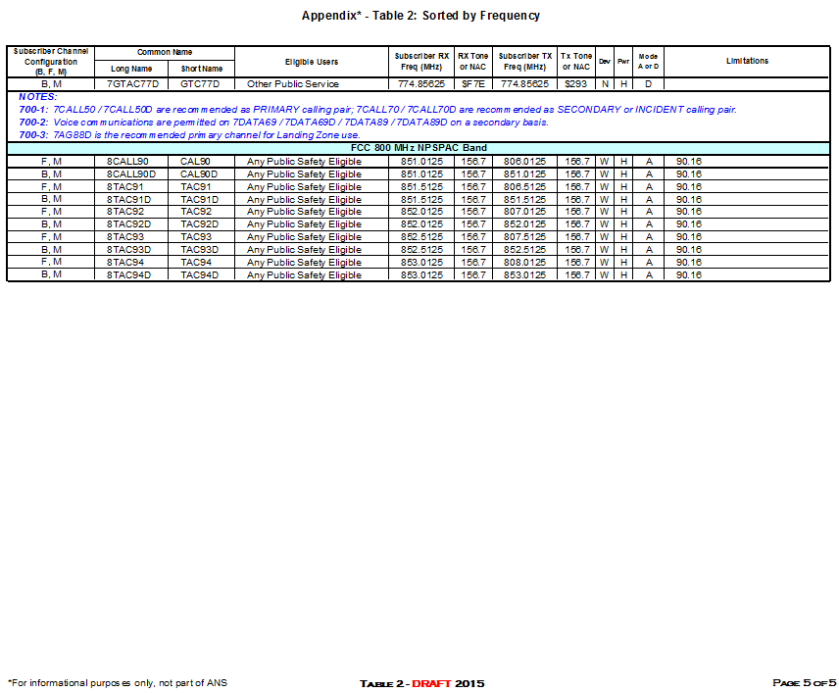

See FCC DA-01-1621A for the existing names and limitations.
Originally each 6 MHz TV channel was allocated as 3 MHz of narrowband voice and 3 MHz of reserve or wideband data use. Channel 63 is paired with Channel 68, and Channel 64 is paired with Channel 69.
The channels so designated were Channel 25 (157.250/162.850 MHz) and Channel 84.
2nd Report and Order In the Matter of Amendment of the Commission’s Rules Regarding Maritime Automatic Identification Systems, FCC 08-208 at 20.
The designator “AG” for Air to Ground was selected to avoid confusion with the “AIR” designator that is used for air to air communications.
VSAR16 is not an FCC designated interoperability channel but is widely used for search and rescue operations. This channel may also be licensed for other purposes.
The Computer Assisted Pre-Coordination Resource and Database System (CAPRAD) is a regional planning tool designed to assist 700 MHz Regional Planning Committees with development of their plans. The Communications Asset Survey and Mapping Tool (CASM) was developed by the Interoperable Communications Technical Assistance Program within the U.S. Department of Homeland Security to assist urban areas, designated metropolitan areas and states with inventory and mapping/use of interoperability resources. The National Interoperability Information eXchange (NIIX) is a library of statewide and tactical interoperability planning documents managed by NPSTC.
Definitions are those found in 47 CFR 90.7
In the FCC’s Report and Order (FCC 14-172 at Paragraph 47) the Commission designated a separate set of 700 MHz frequencies for use by transportable trunking systems. The intent of this designation is that the interoperability channels not be used for deployable trunked radio systems.

