The National Emergency Communications Plan (NECP)
2019 Update Social Media Toolkit

What’s in the Toolkit?
The Cybersecurity and Infrastructure Security Agency’s (CISA) stakeholders have been integral to the development of the updated NECP and will be critical in messaging the release of the document to reach the widest audience. CISA is requesting your assistance in helping publicize the announcement about the updated NECP, available resources, and information on three upcoming webinars using social media or email.
To assist in this endeavor, CISA has drafted a series of scripted messages which include:
- Email Announcement……………………………………………………………………pg. 2
- Blog………………………………………………………………………………………..pg. 3
- Twitter Posts for NECP Release…………………………………………….…………pg. 4
- Facebook/LinkedIn Posts for NECP Release……………………………….………..pg. 5
- Posts for NECP Webinars………………………………………………………………pg. 6
- Images………………………………….…………………………………………………pg. 9

How to use the Toolkit
The draft messages in this toolkit can be used by your organization as is, or you are welcome to tailor them to your audiences. They have been initially designed for use on Twitter, Facebook, and LinkedIn, but can be posted on other internal platforms used by your organization or other social media sites.
In addition, CISA encourages its partners to like, retweet/repost, and share the NECP posts from CISA’s Twitter and LinkedIn pages.
- Twitter: @CISAgov
- LinkedIn: https://www.linkedin.com/company/cybersecurity-and-infrastructure-security-agency

Suggested Hashtag
We have developed the hashtag #NECP2019 and ask that you reference it in your messaging.

Link
NECP Webpage: https://www.cisa.gov/necp

Drafts of Social Media Posts
The following posts have been divided into different categories focusing on the release of the NECP and on the webinars. There are multiple options for your consideration, and we encourage you select the one(s) that will resonate most within your organization. Please remember, you are welcome to tailor the messages or create your own.
- Email Announcement for Associations to Distribute
Subject line: CISA Releases the Updated National Emergency Communications Plan

XXXXXXXXX, 2019

Today, the Cybersecurity and Infrastructure Security Agency (CISA) released an update to the National Emergency Communications Plan (NECP) – the Nation’s roadmap to ensuring emergency communications interoperability at all levels of government.
CISA leveraged the feedback from more than 3,500 public safety representatives from Federal, state, local, tribal, and territorial public safety agencies, non-governmental organizations, and other groups in revising the NECP to ensure it reflects the whole community’s expertise, experience, and needs. The breadth of public safety’s participation makes the NECP a key component of our Nation’s preparedness.
The updated NECP:
- Builds upon the key concepts and principles of the 2008 and 2014 versions of the NECP;
- Revises the Vision statement to address secure information exchange and adds the public to acknowledge their increasing role in emergency communications;
- Emphasizes the importance of strategic and lifecycle planning and sustainable funding;
- Promotes the importance of evaluating and documenting lessons learned from training and exercises;
- Underscores the need for coordination of communications assets and capabilities at incidents and planned events;
- Emphasizes technology and infrastructure lifecycle management and focuses on effective and interoperable information sharing; and
- Adds a new goal focused on cybersecurity risk management, the mitigation of cybersecurity vulnerabilities, cyber hygiene minimums and funding.
We encourage our members to attend one of CISA’s 60-minute webinars, where CISA will discuss the updates to the NECP and answer questions. The dates are as follows:
- Wednesday, October 2, 2019, 3:00 pm – 4:00 pm ET
- Tuesday, October 8, 2019, 4:00 pm – 5:00 pm ET
- Wednesday, October 9, 2019, 11:00 am – 12:00 pm ET
To participate use: webinar link (for visual): https://share.dhs.gov/necp2019 and dial-in (for audio): (800) 381-7839.
To review the updated NECP visit: https://www.cisa.gov/necp or for questions about the NECP, contact: necp@cisa.dhs.gov.
- Blog for Associations to Post

CISA Releases the Updated National Emergency Communications Plan: Enhancing Communications for the Public Safety Community
XXXXXXXXX, 2019
The Department of Homeland Security (DHS) Cybersecurity and Infrastructure Security Agency (CISA) recently released comprehensive updates to the National Emergency Communications Plan (NECP) – the Nation’s roadmap to ensuring emergency communications interoperability at all levels of government.
Organizations with missions to improve public safety interoperability and communications collaborated with CISA on this effort to ensure critical firsthand knowledge of emergency communications challenges, needs, and best practices are reflected in the NECP.
CISA engaged more than 3,500 public safety representatives from Federal, state, local, tribal, and territorial public safety agencies, non-governmental organizations, and other groups in revising the NECP. This process examined lessons learned from real-world incidents, results from the 2018 SAFECOM Nationwide Survey and the 2018 Nationwide Communications Baseline Assessment, and input from stakeholder groups throughout the nation to inform the Plan’s goals, objectives, and success indicators.
Key updates to the NECP include adding a cybersecurity goal, emphasizing the importance of strategic and lifecycle planning, promoting the importance of evaluating and documenting lessons learned from training and exercises, underscoring the need for coordination of communications assets and capabilities at incidents and planned events, and focusing on effective and interoperable information sharing.
To learn more about the updates to the NECP, you can participate in one of three informational webinars CISA is hosting on the following dates:
- Wednesday, October 2, 2019, 3:00 pm – 4:00 pm ET
- Tuesday, October 8, 2019, 4:00 pm – 5:00 pm ET
- Wednesday, October 9, 2019, 11:00 am – 12:00 pm ET
To participate use: webinar link (for visual): https://share.dhs.gov/necp2019 and dial-in (for audio): (800) 381-7839
A copy of the updated NECP is available for download at: https://www.cisa.gov/necp and for questions on the NECP, contact: necp@cisa.dhs.gov.
- Twitter Posts for NECP Release
Option 1
Updates to the National Emergency Communications Plan were just released! Download your copy at https://www.cisa.gov/necp #NECP2019
Option 2
Just released! #NECP2019 was updated to address gaps within emergency communications, reflect new and emerging technological advancements, and provide guidance to drive the nation towards a common end-state for communications. Learn more: https://www.cisa.gov/necp
Option 3
Support for NG911 transition, PSAP cybersecurity, network resiliency, continuity of operations, human factor demands and much more for the 911 community can be found in the #NECP2019. Learn more: https://www.cisa.gov/necp
Option 4
#NECP2019 provides recommendations for _____________ (select from the following list to fill in the blank: law enforcement agencies, fire departments, or emergency medical services) to improve critical incident and event communications coordination to include timely notification, activation, and responses from communications systems providers. Learn more: https://www.cisa.gov/necp
Option 5
Newly released #NECP2019 addresses the need for greater availability of training and exercise programs for ____________ (select from the following list to fill in the blank: law enforcement agencies, fire departments, or emergency medical services) to address gaps in emergency communications. Learn more: https://www.cisa.gov/necp
Option 6
#NECP2019 recommends public safety should implement NIST Cybersecurity Framework, perform a Cyber Resilience Review, develop a cybersecurity incident response plan, and update training and exercise programs to address cybersecurity. Learn more: https://www.cisa.gov/necp

- Facebook/LinkedIn Posts for NECP Release
Option 1
The just released National Emergency Communication Plan (NECP) was updated to address the current gaps within emergency communications, reflect new and emerging technological advancements, and provide guidance to drive the nation towards a common end-state for communications. With inputs from over 3,500 public safety representatives, the updated NECP is the Nation’s roadmap to addressing and enhancing emergency communication capabilities. #NECP2019 #CISA
Learn more about the NECP by visiting https://www.cisa.gov/necp
Option 2
Support for NG911 transition, PSAP cybersecurity, network resiliency, continuity of operations, human factor demands and many more topics for the 911 community can be found in the National Emergency Communications Plan (NECP). The NECP is the Nation’s comprehensive strategic plan to strengthen and enhance emergency communications capabilities. CISA leveraged our organization’s firsthand knowledge of emergency communications challenges, needs, and best practices in updating the NECP. #NECP2019 #CISA
Learn more about NECP here: https://www.cisa.gov/necp
Option 3
The National Emergency Communications Plan (NECP) provides recommendations to improve critical incident and event communications coordination to include timely notification, activation, and responses from communications systems providers. We collaborated with CISA on the recently released NECP to ensure it is reflective of the whole community’s emergency communications expertise, experience and needs. #NECP2019 #CISA
Visit the NECP website to learn more: https://www.cisa.gov/necp
Option 4
The recently released National Emergency Communications Plan (NECP) addresses the need for greater availability of training and exercise programs to address gaps in emergency communications. CISA leveraged our organization’s firsthand knowledge of emergency communications challenges, needs, and best practices in updating the NECP. #NECP2019 #CISA
Learn more about NECP here: https://www.cisa.gov/necp

Option 5
The newly updated National Emergency Communications Plan (NECP) encourages more inclusive governance and planning by incorporating non-traditional entities supporting public safety, such as __________ (select from the following list or add your own example to fill in the blank: tribes, medical facilities, alerting authorities, nongovernmental organizations, public works, utilities, forestry services, military, private sector, or American Red Cross). With inputs from over 3,500 public safety representatives including our organization, the updated NECP is the Nation’s roadmap to addressing and enhancing emergency communication capabilities. #NECP2019 #CISA
Learn more about the NECP by visiting https://www.cisa.gov/necp
Option 6
The newly updated National Emergency Communications Plan (NECP) encourages adaptive and inclusive governance and planning by expanding membership, to include __________ (select from the following list or add your own example to fill in the blank: information management, network infrastructure, cybersecurity representatives, elected officials or other fiscal decision makers). With inputs from over 3,500 public safety representatives including our organization, the updated NECP is the Nation’s roadmap to addressing and enhancing emergency communication capabilities. #NECP2019 #CISA
Learn more about the NECP by visiting https://www.cisa.gov/necp
Option 7
Cybersecurity is one of the new goals in the updated National Emergency Communications Plan (NECP). It encourages public safety organizations to implement the NIST Cybersecurity Framework, perform a Cyber Resilience Review, develop and maintain a cybersecurity incident response plan, and update training and exercise programs to address cybersecurity. Our organization was heavily engaged in the process to develop this goal. For more information read the updated NECP: https://www.cisa.gov/necp #NECP2019 #CISA
- Posts for NECP Webinars
These draft posts are designed to be released in sequence starting immediately after the release of the NECP before each webinar.
Twitter Posts
Overall Webinar Tweet – Release on September 25
Have questions about the #NECP2019? Join one of CISA’s webinars on October 2, 8 or 9 to learn more. View webinar link and call-in information at www.cisa.gov/necp

Webinar #1: Wednesday, October 2, 2019, 3:00 pm – 4:00 pm EDT
- Tweet #1 – Post on October 1
Calling all public safety personnel! Join @CISAgov tomorrow, October 2, 2019 from 3:00 – 4:00 PM EDT for CISA’s NECP webinar. They will be discussing updates and answering questions about the #NECP2019. View webinar link and call-in information at www.cisa.gov/necp
- Tweet #2 – Post on October 2
Have questions about the #NECP2019 or want to find out more about it? Join us today from 3:00 – 4:00 PM EDT for CISA’s NECP webinar. We will be discussing all updates and answering questions about the #NECP2019. Join here: https://share.dhs.gov/necp2019
Webinar #2: Tuesday, October 8, 2019, 4:00 pm – 5:00 pm EDT
- Tweet #1 – Post on October 7
Missed the first NECP webinar hosted by @CISAgov? You have a second chance! Join
#CISA tomorrow, October 8, 2019 from 4:00 – 5:00 PM EDT. They will discuss updates and answer your questions about the #NECP2019. View webinar link and call-in information at www.cisa.gov/necp
- Tweet #2 – Post on October 8
Don’t miss out on all the new revisions made to the #NECP2019! Join @CISAgov today from 4:00 – 5:00 PM EDT. They will be answering any questions you have about the #NECP2019. Take part here: https://share.dhs.gov/necp2019
Webinar #3: Wednesday, October 9, 2019, 11:00 am – 12:00 pm EDT
- Tweet #1 – Post on October 8 (AFTER 4:00 PM Webinar)
LAST CHANCE! Tomorrow, October 9, 2019 from 11:00 AM – 12:00 PM EDT, @CISAgov will be hosting its FINAL webinar for the #NECP2019. Please join us to find out all about the updates made to the NECP or and have any questions answered! View webinar link and call-in information at www.cisa.gov/necp
- Tweet #2 – Post on October 9
FINAL REMINDER! The last #CISA NECP webinar is today from 11:00 AM – 12:00 PM EDT. Learn about the updates to #NECP2019 and have your questions answered. Join here: https://share.dhs.gov/necp2019

Facebook/LinkedIn Posts
Overall Webinar Post - Released on September 25
Interested in learning more about the updates to the recently released #NECP2019? Do you have questions for CISA about the Nation’s roadmap to address and enhance emergency communications interoperability? Join one of the webinars hosted by #CISA on October 2, 8, or 9, 2019.
View webinar links and call-in information here: www.cisa.gov/necp
Webinar #1: Wednesday, October 2, 2019, 3:00 pm – 4:00 pm EDT
- Facebook/LinkedIn #1 – Post on October 1
Join #CISA tomorrow, October 2, 2019 from 3:00 – 4:00 PM EDT for CISA’s NECP webinar. They will be discussing updates and answering questions about the #NECP2019. View webinar link and call-in information at www.cisa.gov/necp
- Facebook/LinkedIn #2 – Post on October 2
Don’t forget to join the webinar hosted by #CISA today from 3:00 pm – 4:00 pm EDT! Learn more about the updates made to the recently released National Emergency Communication Plan. #NECP2019.
View webinar link and call-in information here https://share.dhs.gov/necp2019
Webinar #2: Tuesday, October 8, 2019, 4:00 pm – 5:00 pm EDT
- Facebook/LinkedIn #1 – Post on October 7
Were you unable to attend the first CISA webinar on the recently released National Emergency Communication Plan? There is still time to learn more about the updates to the recently released #NECP2019? Join either of the webinars hosted by #CISA Tuesday, October 8, from 4:00 pm – 5:00 pm EST or Wednesday, October 9 from 11:00 am – 12:00 pm EDT. View webinar links and call-in information at www.cisa.gov/necp
- Facebook/LinkedIn #2 – Post on October 8
Don’t forget to join the webinar hosted by #CISA today from 4:00 pm – 5:00 pm EDT! Learn more about the updates made to the recently released National Emergency Communication Plan! #NECP2019
View webinar link and call-in information here https://share.dhs.gov/necp2019

Webinar #3: Wednesday, October 9, 2019, 11:00 am – 12:00 pm EDT
- Facebook/LinkedIn #1 – Post on October 8 (AFTER 4:00 PM Webinar)
Did you miss the last two webinars hosted by #CISA about the recently released #NECP2019? You’re in luck! They are hosting one final webinar Wednesday, October 9, 2019, 11:00 am – 12:00 pm EDT. Learn about how over 3,500 public safety representatives across all levels of government influenced the updates to NECP.
View webinar link and call-in information at www.cisa.gov/necp
- Facebook/LinkedIn #2 – Post on October 9
Don’t forget to join the final webinar hosted by #CISA today from 11:00 am – 12:00 pm EDT! This is your last chance to ask CISA questions about the updates made to the recently released National Emergency Communication Plan! #NECP2019
Join the conversation here: https://share.dhs.gov/necp2019
- Images
Images for Day of NECP Release – September 25
Option 1
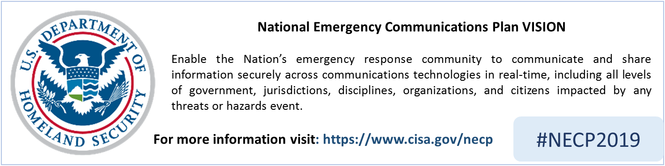
Option 2
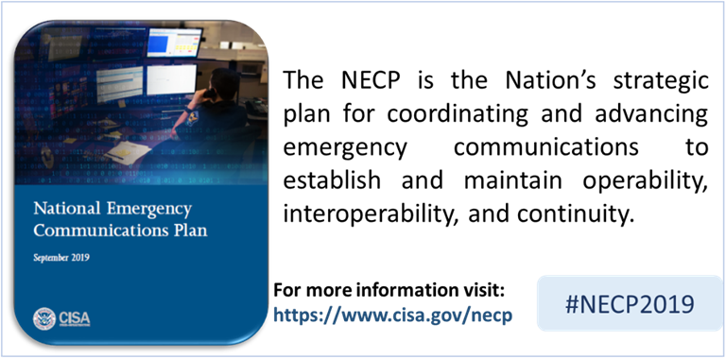
Option 3
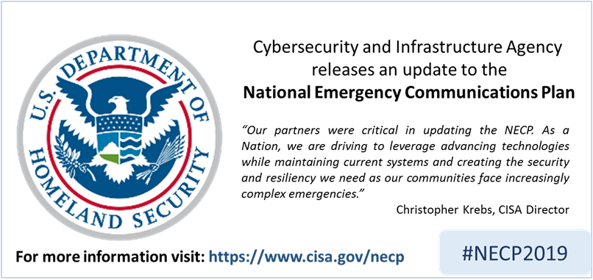
Option 4
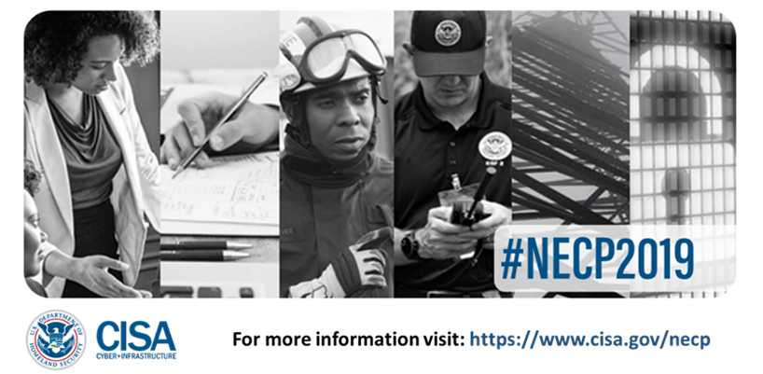

Images for NECP Webinars
Option 1 – Overall Messaging (use between September 25 – October 1)
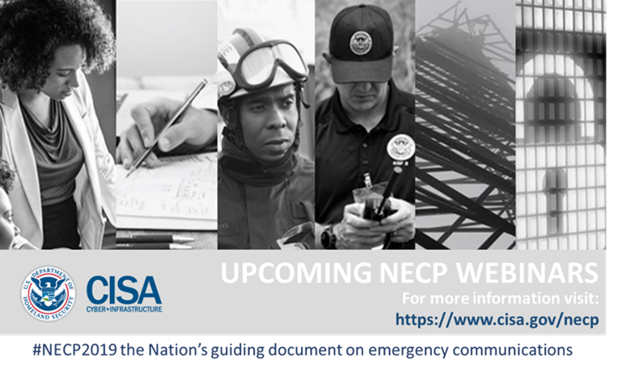
Option 2 – Webinar Details (use between September 25 – October 1)
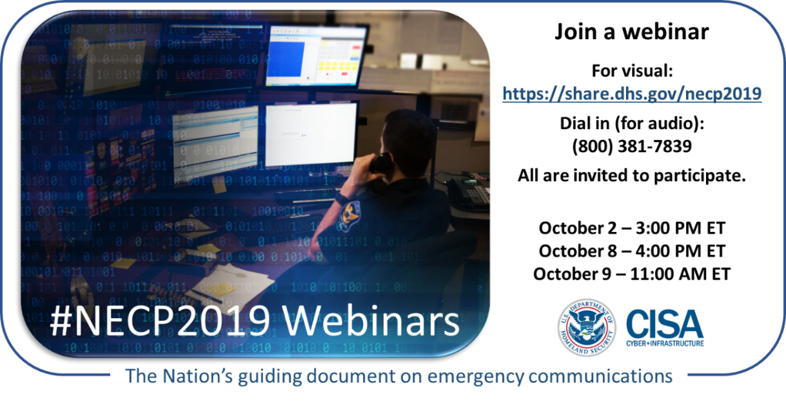

Option 3 – Webinar #1 (use on October 1-2)
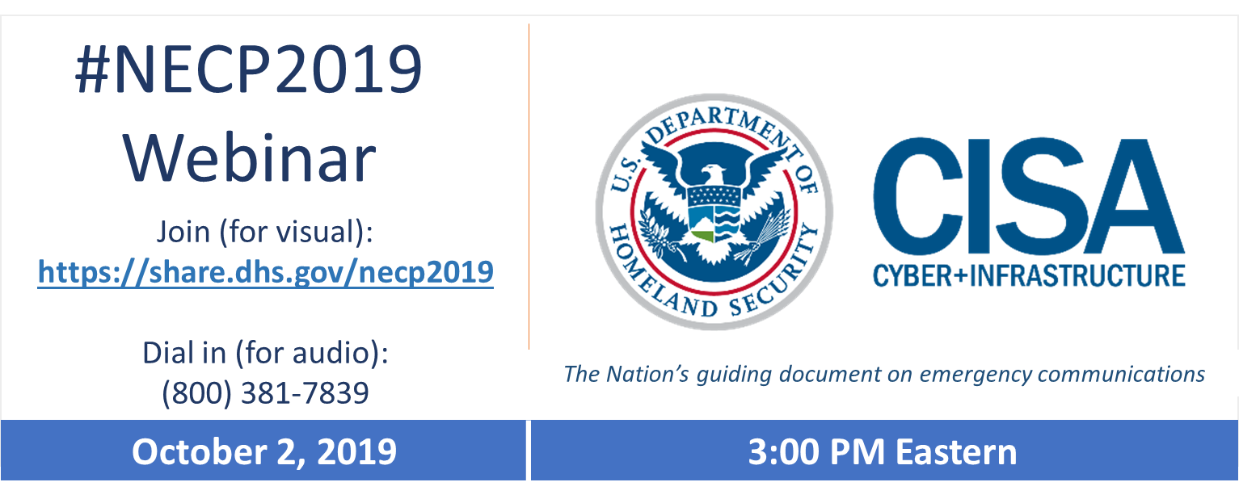
Option 4 – Webinar Details (use between October 3-8)
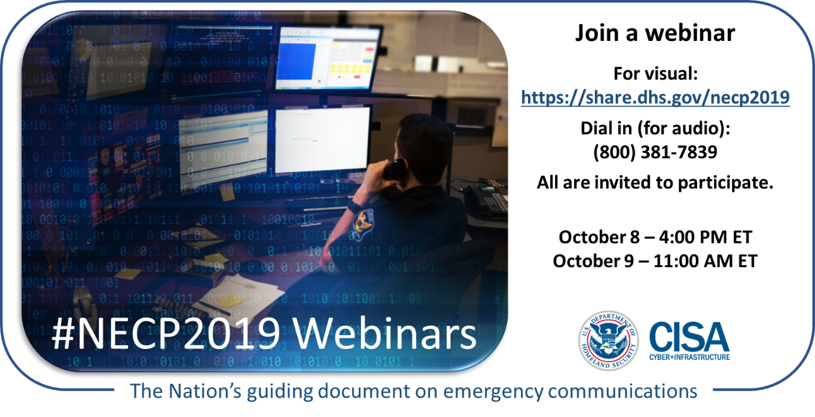
Option 5 – Webinar #2 (use on October 7-8)
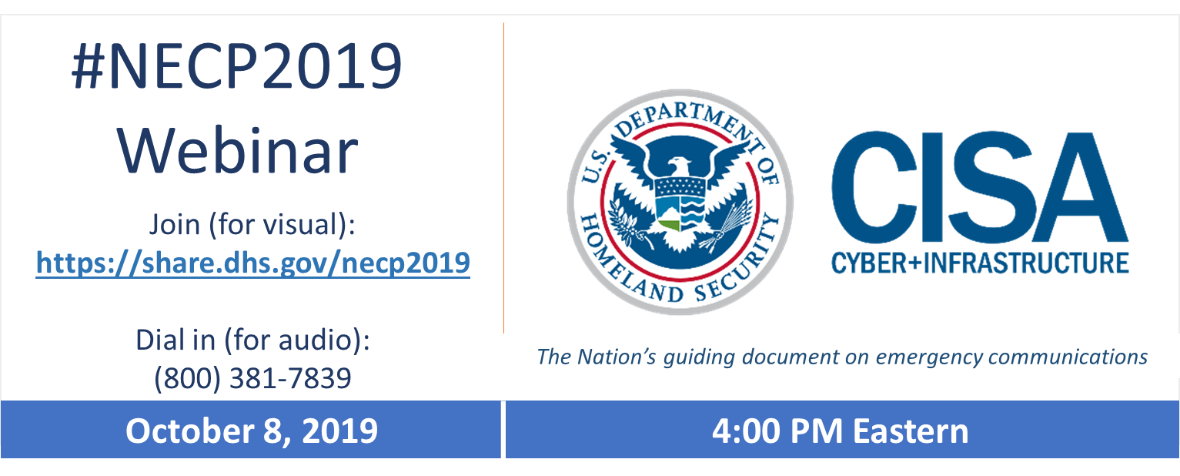
Option 6 – Webinar Details (use October 8-9)
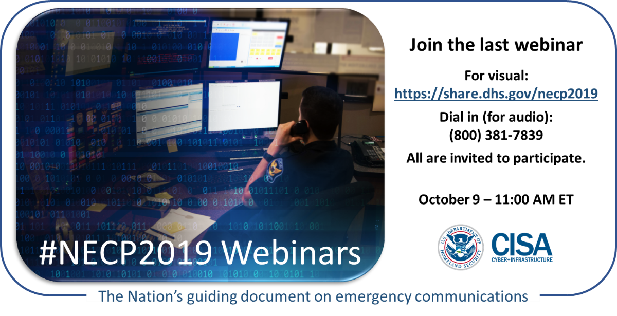
Option 7 – Webinar Details (use October 8-9)
